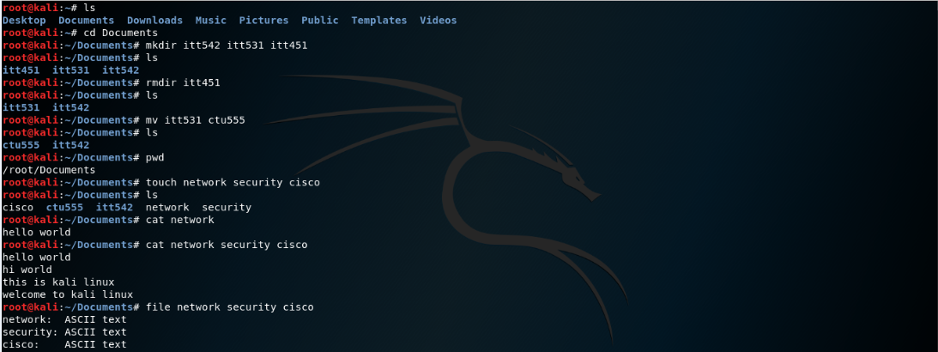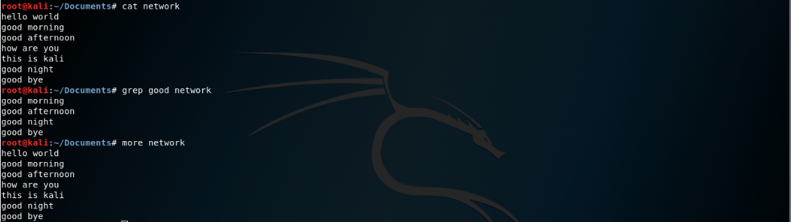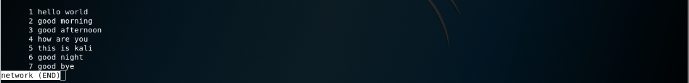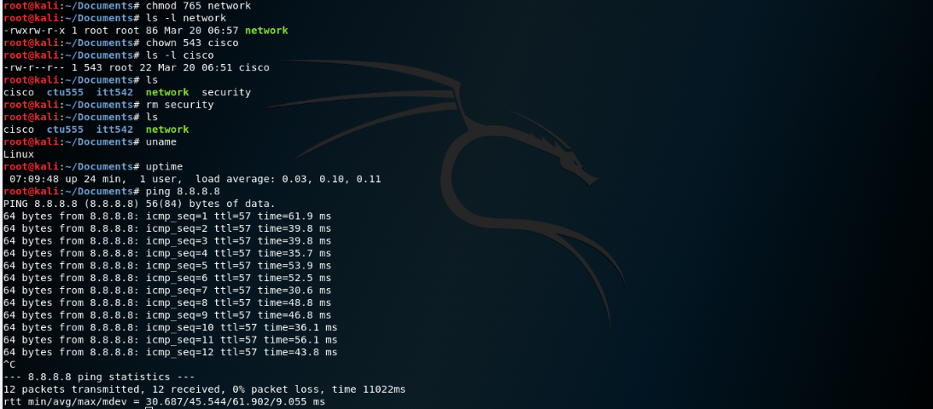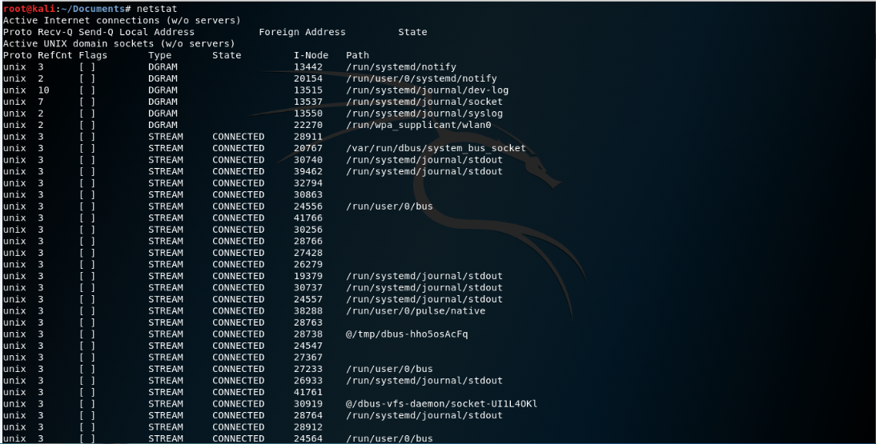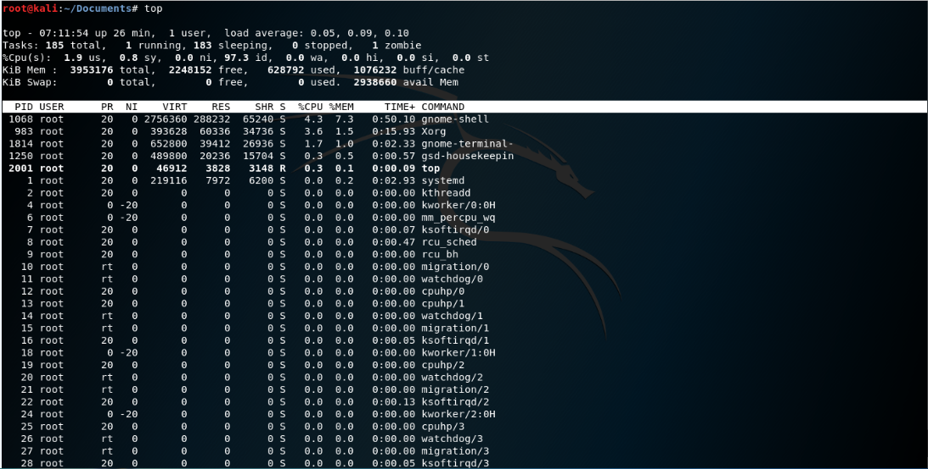

1. **ls**

* the ls command - the list command - functions in the [linux terminal](http://www.informit.com/store/linux-kernel-development-9780672329463) to show all of the major directories filed under a given file system. for example, the command:

1. **cd**

* the cd command - change directory - will allow the user to change between file directories.

1. **mv & rm**

* mv command - move - allows a user to move a file to another folder or directory
* rm command - like the rmdir command is meant to remove files from your linux os

1. **mkdir/rmdir**

* the mkdir - make directory - command allows the user to make a new directory
* the rmdir - remove directory - command allows the user to remove an existing command using the linux cli

1. **touch**

* allows users to make files using the linux

1. **cat**

* cat commands are most commonly used for displaying the contents of a file.

1. **pwd**

* the pwd (print working directory) command displays the name of the current working directory.

1. **file**

* the command file is to determine type of file for example single file, multiple file, viewing mime type and compressed file.

1. **ln**

* ln command is a standard unix command utility used to create a hard link or a symbolic link (symlink) to an existing file.

1. **chmod / chown**

* chmod changes the access mode (permissions) of one or more files. only the owner of a file or a privileged user may change the access mode.
* chown changes file or group ownership and has the option to change ownership of all objects within a directory tree, as well as having the ability to view information on objects processed.

1. **more/less**

* more command ,create more pages through text one screen at a time, but is more limited in moving in files.
* less command lets an admin scroll through configuration and error log files, displaying text files one screen at a time, with backward or forward moving available in files.

1. **grep**

* searches files for a given character string or pattern and can replace the string with another. this is one method of searching for files within linux.

1. **wc**

* wc counts the number of words, lines and characters in text files and produces a count for multiple files if several files are selected.

1. **kill**

* kill command is used on linux and other unix-like operating systems to terminate processes without having to log out or reboot

1. **ps**

* ps reports the statuses of current processes in a system.

1. **top**

* top is a set of protocols for networks that performs distributed information processing in offices and displays the tasks on the system that take up the most memory.

1. **uname**

* uname displays the name of the current operating system and can print information about the system.

1. **uptime**

* uptime tells you how long the system has been running.

1. **ping**

* ping allows a user to verify that a particular ip address exists and can accept requests. ping can be used to test connectivity and determine response time, as well as to ensure that a host computer the user is trying to reach is actually operating.

1. **netstat**

* netstat provides information and statistics about protocols in use and current tcp/ip network connections.